Technology Lesson Plan
Heather M. Jacobs
Towson University

Overview
Students in Mrs. Jacobs' fifth grade class are continuing our unit of Earth a Fine Balance in reading. Students will be continuing to build their background knowledge of hurricanes, preparing for a hurricane and the after mass of this disaster by using a variety of digital resources. The class consists of 21 students. The range of ability is from three years below grade level to on grade level. The students struggle with behavior, decoding, comprehending the text and fluency. The class starts out as a whole group and then the special educator and general educator placed the students into break out groups, according to the range of abilities.
Lesson Description
This lesson fits beautifully under the constructivist theory. According to Piaget students learn best when they are constructing and discovering their own knowledge, versus when a teacher is providing direct instruction ("6 Education", 2015). Students are using Thinglink in order to explore at their own pace and discover knowledge about hurricanes. Constructivist also believe in developing schema and tapping into students already existing schema, or background. The real learning happens when students' schema is changed from them discovering new ideas. In this lesson I am asking for students to call upon their prior knowledge when they are completing the dotstorm, "describe what a hurricane is." This information will show me their schema and then I can see how their schema is changing through the notes they collect and through the closure activity.
The Technological Pedagogical Content Knowledge, or TPACK, framework describes how educators use and understand the integration of three forms of knowledge in order to plan effectively (Koehler, 2012). This technology project fits into the TPACK framework because the teacher needed a clear understanding of the topic; hurricanes, an understanding of pedagogy and knowledge of how the students in this class learn best, and a full understanding of the benefits of using Thinglink. These three forms of knowledge is where the planning of the lesson starts. First, the teacher has to have a clear understanding of the ability of the students and how they learn best. It states above that students in the class are at varying levels, including being on grade level all the way down to students who need a text read to them and a human scribe. With that being said, the educator now has to take into consideration their knowledge of technology. What technology can I integrate in order to reach my learners? What websites will allow me to differentiate the materials so that all my students are being exposed to the same topic but at varying levels? This is when Thinglink was chosen as the best form of technology to use. This website allows me to expose all my students to the same topic and content area, but I can vary the media involved in order to have differentiated instruction. This will allow all students, even my students who need human reader and scribe, to work completely independent and at their own pace. After choosing Thinglink, the teacher then considers the third form of knowledge, content. The teacher had to think if students can access the content area of reading and building background for hurricanes through the technology chosen. Hurricanes have many subtopics within; precautions taken leading up to hurricanes hitting, description of weather, exit routes, aftermath, etc. Thinglink was a great option to use in order to explore this content completely. Students would be able to go to links where they would analyze photos, listen to videos and read articles in order to meet their needs and in order to meet the goal of learning about hurricanes.
Lesson Analysis
According to Moersch, 1995, the levels of technology implementation (LoTi) shifts from teacher centered to being learner centered as teachers progress from one level to the next (p 41). The levels range from a 0- Nonuse, which is a lack of technology overall, to a 6- Refinement, where technology is the process, product and tool to solving real world issues. Within this lesson there are a variety of web tools being used in order for students to explore a topic but not necessarily to produce a product or research their own questions. The students could take it a step farther and use the thinglink to then develop their own questions about hurricanes and other natural disasters, real world issues, where they then could create a presentation/product of their solutions to these issues. This would put students at the center of their interests and their learning.
The beginning of this lesson where the students use dotstorming to showcase their background knowledge of what a hurricane is would be at a level 1, awareness, on the LoTi framework. It is a website that doesn’t change the teacher instruction, just better engages students. Within the thinglink links students are using technology at a variety of levels, depending on their comprehension level as well. Technology is at a level 2, exploration, when students are analyzing diagrams and photos in order to gather information on a topic. They then move to a level 3 and 4, infusion and integration, when students are analyzing spreadsheets and data collection of NASA databases to draw conclusions about the debt a hurricane can cause.
This technology lesson shows the knowledge of the students and incorporates technology in an appropriate manner that leads students to their success. Taking a step farther and having them create a project with the gathered information would further the integration of technology, but that is not always an option due to timelines and school district resources for students.

References
6 Education Theorists All Teachers Should Know Infographic. (2015, December 7). Retrieved March 8, 2018, from https://elearninginfographics.com/6-education-theorists-teachers- know-infographic/
Koehler, M. (2012, September 24). TPACK Explained. Retrieved March 7, 2018, from http://tpack.org/
Moersch, C. (1995). Levels of technology implementation (LoTi): a framework for measuring classroom technology use. Learning and Leading With Technology, 40-42.

Appendix A
Lesson Plan

PREREQUISITES
Students started the Earth a Fine Balance unit a week prior to this lesson. The essential questions were introduced and discussed: How do individuals/characters influence the setting/environment in which they live?
How is the harmony and balance on Earth impacted when nature interacts?
How do humans affect the balance on Earth? Students had the chance to research other disasters, such as forest fires, plane crashes, typhoons, etc. Students are familiar with using the websites ItsLearning and Padlet.

ESTIMATED TIME
1 hour

PURPOSE:
Small Group, Classroom Instruction

GRADES:
5

CONTENT AREAS:
English/Language Arts

COMMON CORE:

College and Career Readiness: Anchor Standards
  - Reading
    - Key Ideas and Details
      - CCSS.ELA-Literacy.CCRA.R.1 Read closely to determine what the text says explicitly and to make logical inferences from it; cite specific textual evidence when writing or speaking to support conclusions drawn from the text.
    - Integration of Knowledge and Ideas
      - CCSS.ELA-Literacy.CCRA.R.7 Integrate and evaluate content presented in diverse media and formats, including visually and quantitatively, as well as in words.

Goals

INSTRUCTIONAL GOALS *
OBJECTIVES
- Given a variety of media resources, students will be able to read closely in order to make inferences and determine key details about the danger of hurricanes.

VARIABILITY
- Students will be asked to take out their computers and use dotstorming for warm up question (Multiple Means of Action and Expression)
- Students will perform the warm up and share their answers by adding to the dotstorm (Multiple Means of Engagement)
- Poster will be hanging as a visual support to show KWL Chart (Multiple Means of Representation)
- General Educator will have students create a KWL chart in their notebook.(Multiple Means of Engagement)
- Groups will be split up according to their ability level in order to differentiate accordingly.
- Hurricane Katrina Thinglink exploration (Multiple Means of Representation and action and expression)
- Speech notes computer website will be used to assist students with their notes. (Multiple Means of Action and Expression)

Assessments

FORMATIVE ASSESSMENTS
- At the end of the lesson, the general educator will provide students with an exit slip. The students will be required to record 4 facts they learned from their resources they explored. They also will have to provide one inference they can come to after analyzing their facts.

Instructional Methods

OPENING

Introduction
- Students will be asked to take out their computers and use dotstorming for warm up question,"Define a hurricane" (Multiple Means of Action and Expression)
- Students will perform the warm up and vote for the definition they believe it correct. (Multiple Means of Engagement)
- Special Educator will comment when she feels necessary, making sure that questions are asked for deeper understanding.

DURING

Introduce New Knowledge
- General educator will discuss dotstorm results, any misconceptions or pertinent facts pertaining to what a hurricane is will be discussed.
- General educator will say, "Today we will create a KWL Chart in order to track our knowledge of hurricanes. This will help us to build background for the chapter books we will begin reading next week."
- Poster will be hanging as a visual support to show KWL Chart (Multiple Means of Representation)
- General Educator will have students create a KWL chart in their notebook.(Multiple Means of Engagement)
- Students will be given 5 minutes to record thoughts for what they know about hurricanes and any questions they have about hurricanes.
- Students will share their recording with an elbow partner. (Multiple means of action and expression)

Model New Skills and Knowledge
- Groups will be split up according to their ability level in order to differentiate accordingly.
- General Educator will then explain the class will be splitting into three groups. Hurricane Katrina Thinglink exploration (Multiple Means of Representation and action and expression)
- Speech notes computer website will be used to assist students with their notes. (Multiple Means of Action and Expression)
- The general educator will direct students to log onto ItsLearning where their differentiated groups are showcased and their link to the Thinglink is displayed.
- Dark blue group- Lower SRI and need for human reader/writer, will use speech notes: Austin, Jan, Josh, Ryan C., Marianne, Allysen (Multiple Means
- Green group- mid level SRI who are just below grade level, some comprehension issues: Nick, Madison, Jackson, Ryan H, Jada, Noe, Aj
- Yellow group- on grade level, no assistance needed: Jack, Milly, Aria, Kalli, Kayle, Lily, Amber, Isabella

Guided Practice
- General Educator displayed the Thinglink on the board (Multiple means of Representation)
- General Educator says, "On the Thinglink you will notice three colors, these three colors represent your group. You will only explore your colored dots."
- General Educator will model scrolling over the links and what they will display.
- Students will complete a chart where they will take notes on each of their links, teacher will display and explain expectations. (Multiple means of enagement)

Independent Practice
- General educator will provide students with an exit slip. The students will be required to record 4 facts they learned from their resources they explored. They also will have to provide one inference they can come to after analyzing their facts.

CLOSING
- Students will open to their KWL chart and record what they learned from the Thinglink they explored.

Materials

MATERIALS AND SUPPLIES
- Laptops
- Exit Ticket
- KWL Chart
- Dotstorm
- SRI score data
- Thinglink
- Chart for notetaking

Appendix B
Thinglink Website
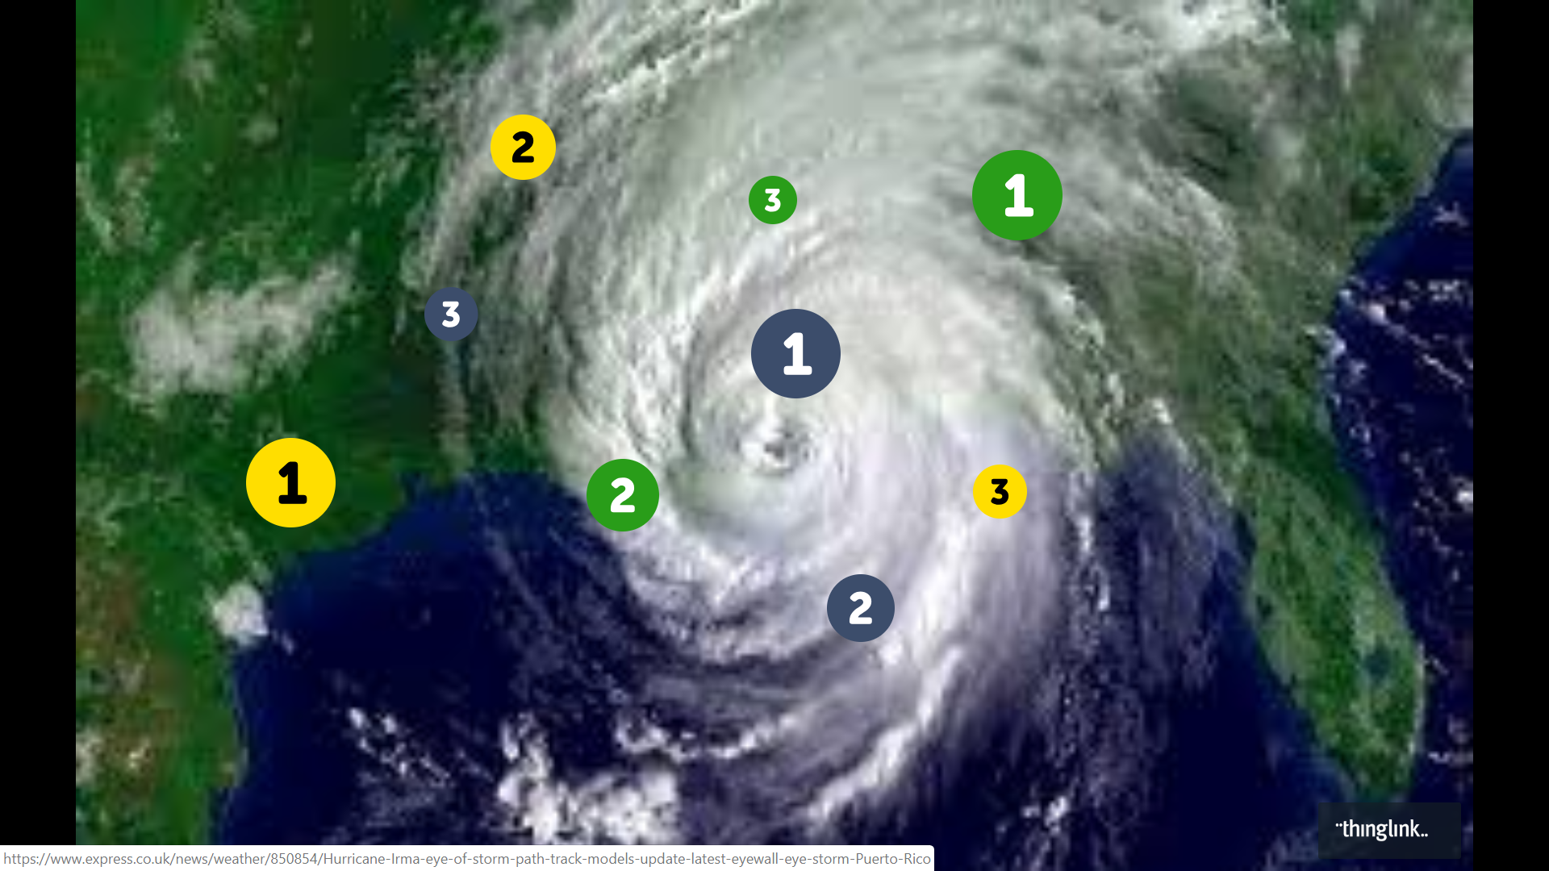

Appendix C
Recording Notes from Thinglink
Blue 1 Description: | Facts:
Blue 2 Description: | Facts:
Blue 3 Description: | Facts:
Green 1 Description: | Facts:
Green2 Description: | Facts:
Green3 Description: | Facts:
Yellow 1 Description: | Facts:
Yellow2 Description: | Facts:
Yellow3 Description: | Facts:

Appendix D
Exit Ticket:
Below record 4 facts you learned from exploring the Hurricane Katrina Thinglink.
1)____________________________________________________________________________
______________________________________________________________________________
2)____________________________________________________________________________
______________________________________________________________________________
3)____________________________________________________________________________
______________________________________________________________________________
4)____________________________________________________________________________
______________________________________________________________________________
Below record an inference you can create from your exploration with the Thinglink:
______________________________________________________________________________
______________________________________________________________________________
______________________________________________________________________________

