Lesson Title  Creating A Digital Citizenship Friendly Classroom | Links | ISTE Standard 2: | Explanation
Day 1: Responsible Digital Citizenship | https://www.commonsense.org/education/system/files/uploads/classroom-curriculum/3-5-unit1-ringsofresponsibility.pdf?x=1 | 2a, 2b, 2c &2d  This lesson will touch on all parts of standard 2 since it will be an introduction to the digital world and digital citizenship. | Day 1’s lesson will introduce digital citizenship; what is digital citizenship, how can I be a good citizen and what responsibilities do I have as a digital citizen. This lesson is the introduction to the heavier topics we will cover over the next couple of days. We will discuss responsibilities of yourself, friends/family, and a larger community. We will discuss what language to use on a digital platform when expressing oneself and when resonding to others. At the end of class we will come up with our digital pledge and each student will sign it.  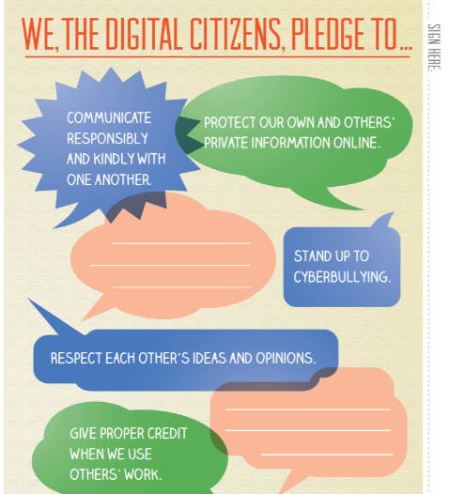
Day 2: Private & Personal Information | https://www.commonsense.org/education/lesson/private-and-personal-information-3-5 | 2a & 2d  This lesson will identify to students what public versus private information is. It will also help students become aware of their digital footprint, once something is out there you cannot take it back. | This is a very important lesson that students need to realize just how important it is. Today we will be discussing what in fact is private information versus what can be public information. We will also be discussing not only the information that should be shared by pictures that should versus shouldn’t be shared. For example, discussing how putting up a picture and tagging someone else is wrong unless you have permission from them. Also, making sure that the background of pictures doesn’t display private information. There is an assessment at the end of this lesson.
Day 3: What is Cyberbullying? | https://www.commonsense.org/education/lesson/whats-cyberbullying-3-5  http://www.digizen.org/resources/cyberbullying/interactive/ | 2a & 2b  This lesson defines cyberbullying which truly will effect a student’s digital identity and reputation. This lesson explains that we need to be positive, save, respectful and ethical when using technology and interacting with others. | This lesson and the next lesson are the most important lessons, in my opinion. Society is so quick to make judgements and post the first thing that comes to their mind because it is easy to do digitally. These next two lessons will incorporate different scenarios students will read and must determine if it is cyberbullying, why it is/is not, who is involved, and strategies to solve the situation. Students not only need to understand how to be respectful and the language they should be using, but they also need strategies for when they come into contact with someone else who is not using appropriate language. The second part, Power of Words, will discuss how students should respond to others who may not be using the respectful language. There is a cyberbullying game to play at the end of these lessons if time allows.
Day 4: Power of Words | https://www.commonsense.org/education/lesson/the-power-of-words-3-5  https://www.commonsense.org/education/digital-passport  (Cyberbullying passport game) | 2a & 2b  This lesson is a continuation of cyberbullying which explains the safe, respectful language they should be using on digital platforms. It also helps with how students should respond to others who may not be showcasing good digital citizenship. | SEE ABOVE
Day 5: Whose is it Anway? | https://www.commonsense.org/education/lesson/whose-is-it-anyway-3-5  https://www.commonsense.org/education/lesson/how-to-cite-a-site-3-5 | 2c  This lesson will help students understand how to give credit when using digital resources. Finding out who to give credit for and how to cite the source will be included in this lesson. | This is an important lesson for students in order to give credit when credit is due! Students will learn what copy right is along with plagiarism. Students will be learning how to identify who to give credit too when using information from a source. Students will also be learning how to cite the sources used and not plagiarize. Students will be given scenarios that they will have to determine if plagiarism occurred or if the right credit was given. There is also an assessment at the end.  -One thing students forget is even if they are using a picture from google, they should be citing the source!
Day 6: Digital Citizenship Hero! | https://www.teachingchannel.org/video/teaching-digital-citizenship  file:///C:/Users/Heather/Downloads/3_5_unit_superdigitalcitizen.pdf  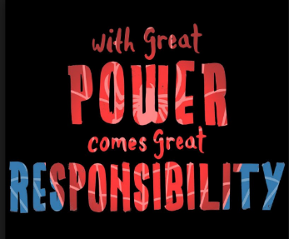 | 2a, 2b, 2c & 2d  This is a fun way to wrap up everything that was taught to students about digital citizenship. Their creative problem and solution will show their understanding of Standard 2. | Today we will create a comic of super digital hero- Students will create a narrative problem to put their super hero in. This narrative problem will be a digital citizenship problem that the super digital hero will have to use their citizenship skills to solve. This is a fun way to show students’ understanding of the importance of digital citizenship.

